TNR (THE NEW REPULIC)

May 22, 2020 by Jo Livingston

The Two Lives of Norma McCorvey

The documentary “AKA Jane Roe” is a lesson in how the law dehumanizes those it claims to protect.
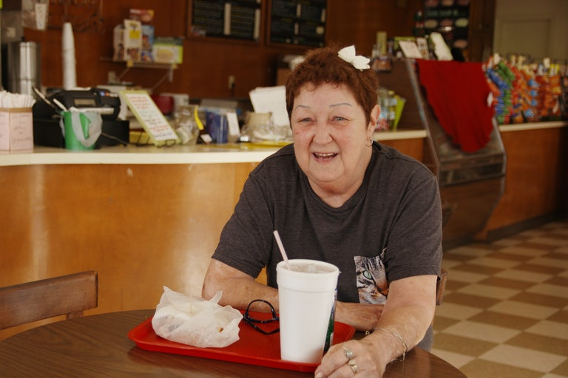
(COURTESY OF FX)
Norma McCorvey
The law is written in words, and words are not the same thing as people. In the 1973 landmark lawsuit Roe v. Wade, for example, the plaintiff “Jane Roe” was not the same person as Norma McCorvey. The latter was a poor young woman, 21 years old and long inured to abuse, seeking an end to her third pregnancy when attorneys Linda Coffee and Sarah Weddington found her, in Texas, in 1969. Vulnerable, scared, and rebuffed by Texan doctors, Norma was the perfect plaintiff.
Those lawyers created Jane out of the raw material of Norma. At the Supreme Court, their creation eventually enshrined the right of American women to reproductive freedom. But in the four years during which the case made its way through the legal system, Norma McCorvey continued to live. She never attended any of the hearings or, indeed, underwent any abortions. It wasn’t long after giving birth that Norma met Connie Gonzalez, her female partner for decades to come—an ironic twist in the case law of heterosexual reproduction that I particularly enjoy.
By the time the Roe v. Wade ruling was handed down, there were two McCorveys: Jane, the symbol of women’s inalienable reproductive rights in the face of male chauvinism, and Norma, the tough, funny young woman who found some stability in a queer relationship. Such is the fate of people the law turns into symbols: Their real selves disappear, overshadowed by the forces that use them.
The two different versions of McCorvey collided this week, with the release of the documentary AKA Jane Roe, a portrait of McCorvey in her final years that includes several brand-new interviews with her. Although she had stumped for abortion rights activists in the 1970s and ’80s, McCorvey later flipped to the anti-abortion side and became a powerful counter-symbol to the woman at the heart of Roe. In a deathbed confession, she revealed to the documentarians that evangelicals paid her to switch sides. She also said she had resented being treated snobbishly by left-wing feminists, who thought she was too uneducated to give speeches in public.
Though the revelation made headlines this week, we knew some of this story already. As journalist Debbie Nathan noted in a blog post, she wrote about McCorvey’s ambivalent exit from the feminist left in The Village Voice back in 1996, when she reported that the evangelical preacher Flip Benham had coaxed McCorvey into the movement by manipulating her emotionally. Later, in 2013, Joshua Prager reported in Vanity Fair that Benham, who baptized McCorvey and is viciously homophobic, “helped work out an $80,000 deal for [her] second book,” just before Norma was “born again” and started introducing Gonzalez—her lover of many years—as her “aunt” at his publicity events.
AKA Jane Roe is dedicated to giving McCorvey the last word in a conversation she was long shut out of, and it does clarify some of the details of her story. But it isn’t exactly a revelation that cash greased the wheels of Norma’s conversion. It is new, however, to see Flip Benham yell, “She chose to be used!” on-screen, his televangelist grin wizened with age. The mask of twentieth-century-style televangelism has slipped all the way off, revealing the dark egos of its preacher-leaders. McCorvey is dead, and AKA Jane Roe frames itself as her final legacy. If she died wanting to tarnish some evangelical reputations, then she certainly got her wish.
The white, college-educated leaders of the 1970s abortion rights lobby get a bruising here, too. Amid the litany of horrors McCorvey experienced, their disdain ranks pretty high. In Nathan’s 1996 piece about McCorvey, for example, she described her as a “rough-spoken, uneducated, unsophisticated woman,” who displayed “disturbing neediness and impulsiveness.” But what else could be expected of the ideal candidate for Roe v. Wade, which hinged on the plaintiff’s vulnerability and lack of options? “She couldn’t discuss feminist theory or the details of abortion legislation,” Nathan wrote, but she could “tell a powerful tale of what it was like to be poor, ignorant, and unwillingly pregnant in 1969.”
The way Nathan puts it, the “authenticity” of McCorvey’s story invalidated her political voice, and vice versa. She was caught in a paradox. That’s what the courts do when they make general rulings based on individual cases: They cut a story out of a person’s life, make a law out of it, and then leave the pieces on the floor. Once we understand that, McCorvey’s anti-abortion rebellion makes perfect sense. A chance to make some cash and piss off Gloria Steinem? No wonder she made the leap.
It felt good to meet the real Norma McCorvey on-screen in AKA Jane Roe. She was funny, glamorous, queer, and—ultimately—honest about all those things. With one drawn-on eyebrow arched, she quips, “I wish I knew how many abortions Donald Trump was responsible for, but I’m sure he’s lost count … if he can count that high.” On a trip to the nail salon from the nursing home one day, she houses a complimentary mimosa before saying, in mock surprise, “Gee! Someone drank all mine.”
When McCorvey died, in 2016, the documentary shows, her funeral turned into a grotesque pageant, complete with a Flip Benham sermon. AKA Jane Roe presents itself as her real funeral, a final chance for her own story to shine.
In the end, it was the woman, not the confession or the Supreme Court case, that made McCorvey’s deathbed special. The film joins her in the nursing home, as one of her daughters and two granddaughters gather at the bedside. McCorvey looks up at them and says, “You look so pretty,” her gaze swiveling between their faces. “Alike!” she says, “You look so alike,” as if the reality of her own reproductive history was finally sinking in. Jane Roe had finally left the room.
Jo Livingstone @Jo_Livingstone
Jo Livingstone is a staff writer at The New Republic.

